**Assignment- 1 Figures**

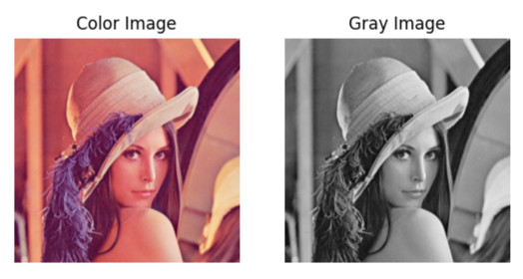

Fig-1: Gray Image Read

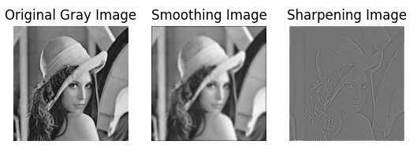

Fig-2: Smooth and Sharp Image

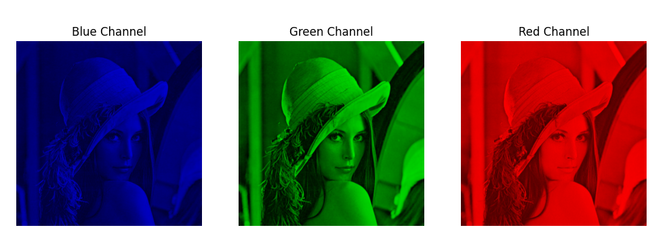**Assignment-2 Figures**

Fig-1 Split RGB Channel

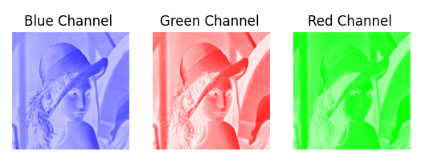

Fig-2 Applying Smoothing Kernel to Each

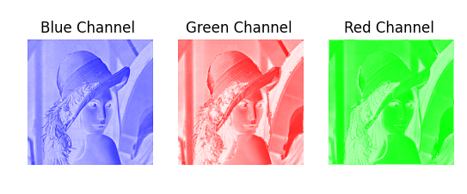Channel

Fig-3 Applying Sharpening Kernel to each

Channel

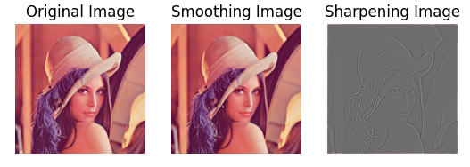Fig-3 Original Smooth and Sharp Image Comparison

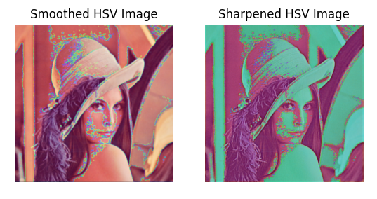

Fig-4 Applying Smoothing and Sharpening kernel on

HSV image